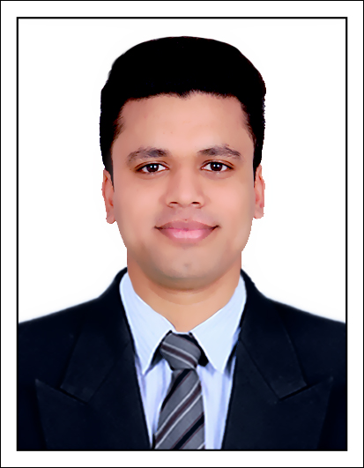­

PINJARI

IRFAN

Sr.Software Test Engineer

**CAREER OBJECTIVE:**

To work in a challenging position with a progressive organization offering opportunities for growth and advancement as **Sr.Automation Test Engeneer**

­

**PROFILE:**

Currently I am warking as **Sr.Software Test Engineer** for TestYantra Software Solutions(India) Pvt Ltd. hyderabad. From 20 june 2022 to Present date I have overall 5.8 years experience in Software Testing including Automation and Manual Testing

**Contacts :**

CONTACTS

**LIG-259Near Dhanalaxmi**

**Center KPHP phase 1**

**Kukatpally, Hyderabad**

**Pin-500072**

**Email: pinjariirfan7878@gmail.com**

**Mobile: +917878790127**

* **Professional Summary:**
* Experience in **Analyzing functional** requirements and translate them to Test Cases.
* Well acquainted with **Software Development Life Cycle** (SDLC) and **Software Testing Life Cycle** (STLC).
* Involve in **Smoke Testing,Integration Testing,System Testing,Regression Testing and Compatibility Testing**
* Experience in writing Test Cases and Executing the Test Cases.
* Good Exposure on **Bug Life Cycle**.
* Experience in Functional, Integration and System Testing.
* Experience to write test cases in Postman for API testing
* Use to work ALM & jira for writing test cases,bugs report & tracking daily work flow
* Expertise in **Selenium WebDriver**.
* Involved in **Group, Parallel and Batch** Execution.
* Involved in handling frames,tables,scrolldown,screenshot ,popup,new window
* knowledge of FW(data driven,Keyword driven,method driver,testNG and basic of hybrid FW)
* Defect Analysis and Reporting using **TestNG**.
* Worked with Apache **POI Library** to get data from external Excel sheet
* Experience in creation of Object Repository.
* Automated Test Cases using Framework
* Good Knowledge on **POSTMAN & New Man**.
* Good Knowledge on **http Request** and **http Response** .
* Experience in API testing using **Rest Assured Framework** .
* Validated **JSON** formatted **data** , different http **status codes**
* Good Exposure on **GIT Commands & handling Conflict**
* Good Knowledge in **CRUD operation**, **Authentication** and **Assertion**

Using Rest Assured

**Personal Details:**

Name : Pinjari Irfan Harun

DOB : 23/09/1993

Marital status : Married

Passport No : N9799730

Email :

Pinjariirfan7878@gmail.com

Contact No : 07878790127

* Selenium WebDriver
* Manual Testing
* Automation Testing
* Core java
* API Testing
* Selenium
* Postman
* REST_Assured
* Jira
* ALM
* TestNG
* Maven

TTT

**Technical Skills:**

**Tools:**





|  |  |
| --- | --- |
| **Client Company:** Wipro | **Platform:** CRM |
| **Designation:** Automation test Engineer | **Project_3:** Ecnomus |
| **Duration:** 2.8 year | **Domain:** Sales |

**Project Summary:**

CRM stands for customer relationship management. It's a set of integrated, data-driven software solutions that improve how you interact and do business with customers.

**Responsibilities:**

* Prepared Automation Test Scripts
* Involved in identifying End to End scenarios and prepared reusable Components.
* Used TestNG in developing Test Scripts using annotations.
* Involved in adding X-Path to repository.
* Experience in API testing using Rest Assured Framework
* Worked on POSTMAN & New Man for cross check for API testing
* Perform CRUD operation for API testing
* Worked on http Request and http Response .
* Submitted status reports on daily and weekly basis for defects testing.
* Raised bugs and provided solutions to overcome those bugs

|  |  |
| --- | --- |
| **Client Company:** Boodmo.com | **Platform:** Android Application |
| **Designation:** Manual test Engineer | **Project_2:** Namoshee |
| **Duration:** 7 months | **Domain:** Sales & supplier |

**Project Summary:**

Boodmo is an online marketplace of automotive components and products. Where a customer can get an Original parts of vehicle and also supplier can sell its product its original parts of vehicle

|  |  |
| --- | --- |
| **Client Company:** Rio Tinto,London | **Platform:** ERP |
| **Designation:** Manual test Engineer | **Project_1:** Madar |
| **Duration:** 2.5 years | **Domain:** Manufacturing |

**Project Summary:**

Enterprise Resourece planning (ERP) is software designed to help organization to store data , manage data,use data regarding theire daily communication in each department as per operation and regular processes.

**Responsibilities:**

* Involved in understanding the requirement and reviewing the requirement & Interaction with the developer team for fixing of bugs.
* Actively participated in creation of necessary test documents.
* Experience on Type of testing (Functional,Integration,System And sanity testing)& Managed impact area analysis across release.
* Regressively done Regression Testing for both Build level and Release Level and also involved in handling over the Regression test suite.
* Participated in requirement analysis, reviews, working sessions to understand the requirements and system design
* Involved in identification of performance scenario

**DECLARATION:**

Hereby I declare that all the information mentioned above is true to my Knowledge and I bear the responsibility for the above mentioned particulars.

**DATE: Your Faithfully,**

**PLACE: SURAT,GUJARAT PINJARI IRFAN H.**

**B.E – ELECTRICAL** (2013 –2016)

Government Engineering College, Bharuch.

Gujarat Technological University Chandkheda,Gujarat,India.

CGPA : 8.74

CPI : 8.42

**DIPLOMA-ELECTRICAL** (2010-2013)

Dr. S & S. S. Ghandhy College of Engineering & Technology, Surat.

Gujarat Technological University Chandkheda,Gujarat,India.

CGPA : 8.53

CPI : 8.39

**S.S.C**-(2010)

Gujarat Secondary & Higher Secondary Educational board, Gandhinagar.

Percentage : 77.23%



* KT Trainer
* Two time employee of the month
* Fire fighter and First Aider
* Information Technology Enable service from Government of Gujarat.

**Professional Experience :**

**Education**